Algebra 1: Unit 6, Lesson 6

- Jeffrey is going on vacation and has a budget of $\$225$ to spend on renting a car. The agency rents cars for $\$27$ per day plus $\$0.80$ per mile driven. The situation can be represented by the inequality $27x+0.8y≤225$, where $x$ is the amount of days and $y$ is the amount of miles driven.
Determine if the point $(-4,6)$ is a viable solution or not and why.
It is not a viable solution because a car cannot be rented for a negative number of days.

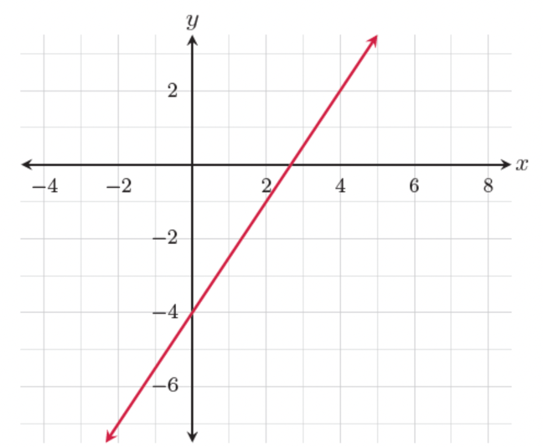
- A line is shown on the graph.

What is the equation of the line in slope-intercept form?
$$y=\frac{3}{2}x-4$$

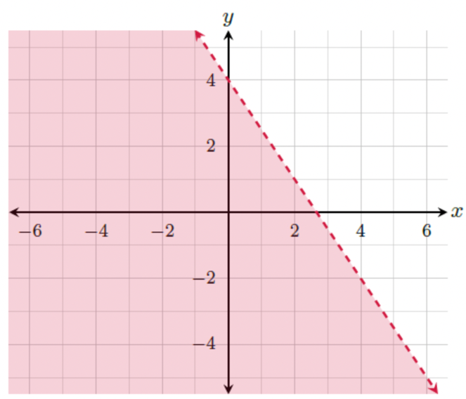
- The linear inequality $2y<-3x+8$ is shown on the graph.

The coordinate $(2,1)$ __________ a solution to the inequality.
is not

